Validation Test for LEVEL 3
Answer one of the two questions (only one of them)
Question 1: transform the following flowchart into pseudocode
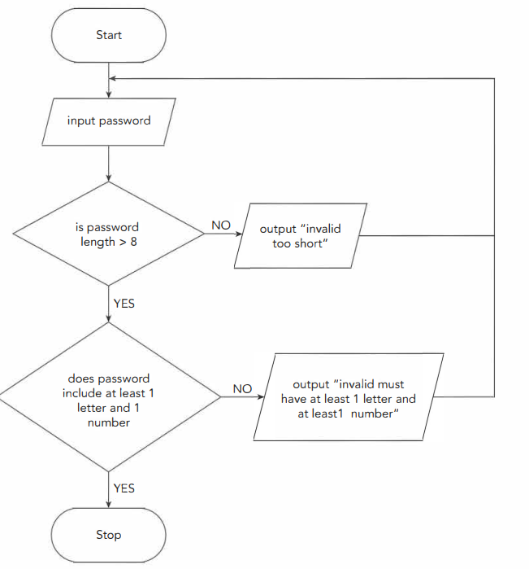 | Equivalent Pseudocode:  ………………………………………………….  ………………………………………………….  ………………………………………………….  ………………………………………………….  ………………………………………………….  ………………………………………………….  ………………………………………………….  ………………………………………………….  ………………………………………………….  ………………………………………………….  ………………………………………………….  ………………………………………………….

Question 2: Write pseudocode that reads an integer Day.
- If the value is less than 1 or greater than 7, output "Invalid"
- Otherwise, output "Valid"
……………………………………………………………………………………..
……………………………………………………………………………………..
……………………………………………………………………………………..
……………………………………………………………………………………..
……………………………………………………………………………………..
……………………………………………………………………………………..
……………………………………………………………………………………..
……………………………………………………………………………………..

